**SWISS KRONO TEX at EuroShop 2017**

February 2017 – On March 5th to 9th of this year, SWISS KRONO TEX will exhibit at EuroShop for the first time. At Stand D32 in Hall 10, it will display extremely robust laminate floors, OSB boards suitable for every imaginable shop architecture and a large range of furniture boards.

**KRONOTEX Laminate Flooring That Meets the Greatest Expectations**

The laminate floors of the KRONOTEX MAMMUT, MAMMUTplus and ROBUSTO collections take the constant pounding typical of heavily trafficked shop floors in stride. Featuring utilisation class 33 and abrasion class AC 5, they effortlessly absorb the brutal impacts of high heels and heavy work boots as well as the abuse of passing wheeled suitcases, shelves being shifted, or even the gyrating heels of dancing staff and customers at company shindigs. The decors are strikingly attractive with their authentic natural wood looks, and some of them are also three-dimensionally embossed in perfect register to reinforce the impression of real wood by making it feel genuine as well.

ROBUSTO: With a 12mm-thick, highly compacted fibreboard core and an exceptionally rugged surface, the floors of this collection tolerates just about anything it comes into contact with.

MAMMUT: This family is characterised by extra-long panels that look just like natural wood. Their length of 1845mm enhances the impression of country-house-style plank floors.

MAMMUTplus: boasting an XXL format that is both extra-long and extra-wide, decorated by attractive natural wood colours and an impressive embossed-in-register structure.

**Furniture Boards for Bespoke Surfaces**

The French firm of the international SWISS KRONO Group will showcase new furniture boards of the ONE WORLD FRENCH COLLECTION. This selection of trendy decors for every decorating style spans a large number of intensive colours, materials, designs and surface structures: an enormous pallet of possibilities for turning original ideas into reality. Dashing and chic designs inspired by original natural materials round off the collection in 2017.

**Large OSB Boards for Fast, Straightforward Shop Construction**

SWISS KRONO OSB is an ideal material for quickly, simply and flexibly building the floors, walls and ceilings of shops. And large-format SWISS KRONO OSB **Long**boards greatly accelerate the pace of work with their length of up to 18 metres. As they lend themselves excellently for flexible prefabrication, even unusual and complex architectural ideas can be implemented with them. Apart from its enormous potential for constructive uses, SWISS KRONO OSB is also an excellent choice for unfinished interior surfaces – for example, presentation walls or displays.

**Images**

The following images are available in print-ready resolution for downloading. They may be used in publications free of charge **provided that they are credited as indicated**.

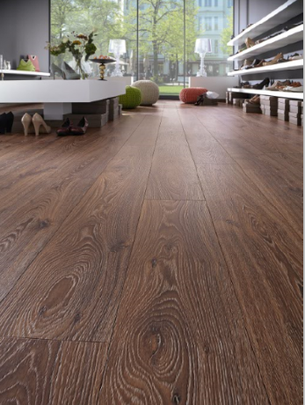 ROBUSTO: the decor Timeless Oak (D 3590) (picture credit: SWISS KRONO TEX GmbH & Co. KG)

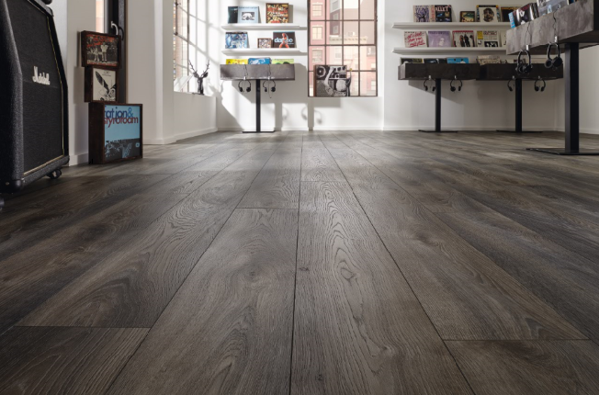MAMMUTplus: the decor Macro Oak Grey (D 4792) (picture credit: SWISS KRONO TEX GmbH & Co. KG)

 MAMMUT: Capitol Oak Medium (picture credit: SWISS KRONO GROUP | photographer: Vogelsänger)

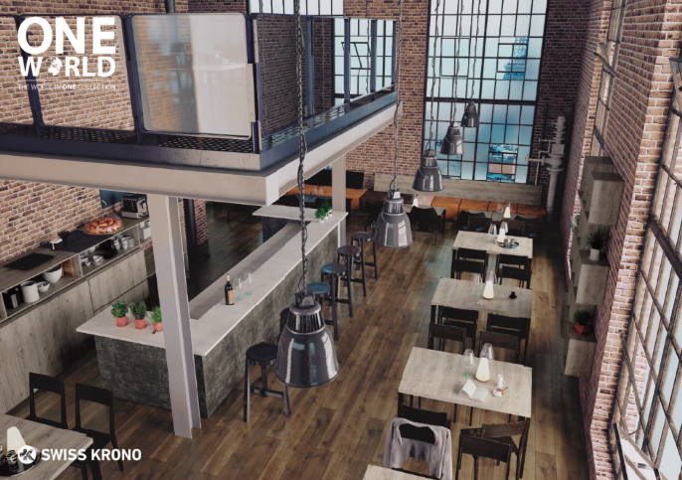 Inspired by natural materials, the designs of the ONE WORLD FRENCH COLLECTION ensure a unique look (picture credit: SWISS KRONO SAS)

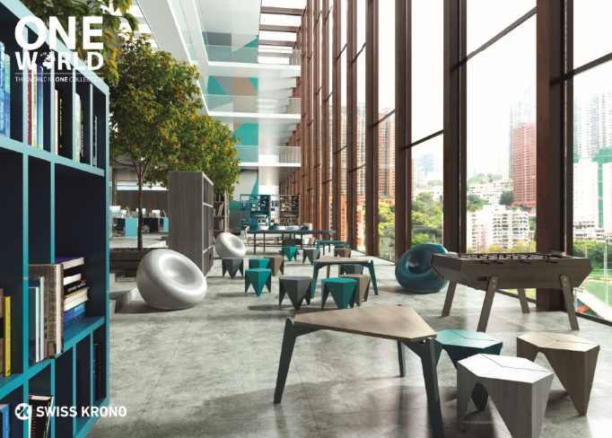 Trendy new colours in the ONE WORLD FRENCH COLLECTION (picture credit: SWISS KRONO SAS)

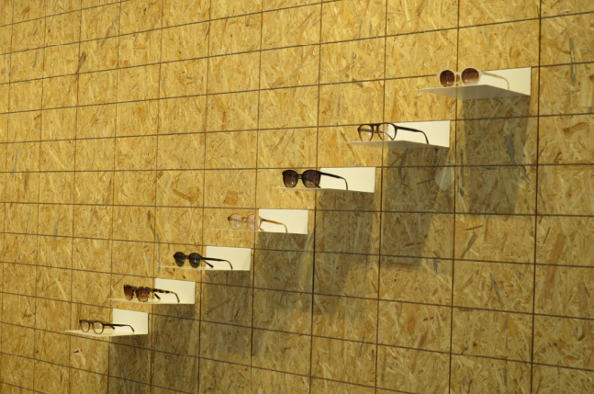 Exposed SWISS KRONO OSB: an original way to present eyeglasses against an OSB wall (picture credit: SWISS KRONO GmbH)

**Über die SWISS KRONO TEX GmbH & Co. KG**

Originally established in 1993 as KRONOTEX GmbH & Co. KG, the core competence of SWISS KRONO TEX GmbH & Co. KG is producing premium laminate flooring. A member of the globally successful SWISS KRONO GROUP, SWISS KRONO TEX ranks amongst the world’s leading laminate flooring manufacturers. At the firm’s works in Heiligengrabe, Germany, more than 700 staff employ an environmentally sound process to produce healthy laminate flooring and eco-friendly engineered wood (OSB). SWISS KRONO TEX exports to more than 80 countries.

|  |  |
| --- | --- |
| **Press Contact**  Ute Bachmann  Tel.: +49 (0) 176 99938586  Fax: +49 (0) 3222 3350590  Email: [u.bachmann@werbeagentur-nowack.de](mailto:u.bachmann@werbeagentur-nowack.de) | SWISS KRONO TEX GmbH & Co. KG  Wittstocker Chaussee 1  16909 Heiligengrabe  Germany  [www.swisskrono.de](http://www.swisskrono.de) |